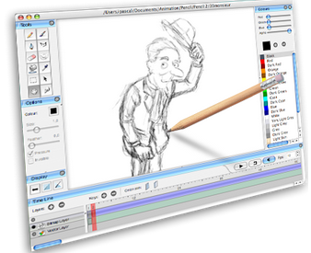**Sketching Program**

Computer Science Software Engineering

Learning Objectives

Students will be able to demonstrate mastery of …

1. Infinite loops in Python
2. Keyboard controls in Python

Procedure

1. Review basic turtle commands for use in your drawing program.

|  |  |
| --- | --- |
| **Basic Turtle Commands** | |
| def() | creates a function call |
| fd() | moves turtle forward |
| bk() | moves the turtle backwards |
| lt() | turns the turtle left |
| rt() | turns the turtle right |
| color() | changes color of line |
| pu() | stops drawing |
| pd() | continues drawing |
| goto() | relocates the turtle to screen location |
| circle() | draws a circle |
| clear() | clears screen |
| reset() | resets screen |

1. You can now use this basic code to create a rudimentary sketching program in Python.

|  |  |
| --- | --- |
| 1 | import turtle |
| 2 | t=turtle.Turtle() |
| 3 | t.screen.title(“My Sketching Program”) |
| 4 |  |
| 5 | def ahead(): |
| 6 | t.fd(30) |
| 7 | def back(): |
| 8 | t.bk(30) |
| 9 | def left(): |
| 10 | t.lt(30) |
| 11 | def right(): |
| 12 | t.rt(30) |
| 13 |  |
| 14 | t.screen.onkey(ahead,”Up”) |
| 15 | t.screen.onkey(back,”Down”) |
| 16 | t.screen.onkey(left,”Left”) |
| 17 | t.screen.onkey(right,”Right”) |
| 18 |  |
| 19 | t.screen.listen() |
| 20 | turtle.mainloop() |

Assignment

Modify the code to create a more complex drawing program that meets the following standard:

1. Lifts and lowers the pen
2. Erases
3. Changes pen color

To exceed the standard (add one or more of the following):

1. Fill shapes with specified color
2. Erase color within shapes
3. Uses mouse controls